**Assignment 1:**

Deploy a Pod which serves a static file. The static file should be created when the Pod starts (init container). The pod is able to serve traffic only if the file exists. Gets restarted if the file is deleted. Also, configure liveness and readiness probes

**Solution:**

Created Pod with below pod definition:

**apiVersion**: v1

**kind**: Pod

**metadata**:

**name**: init-demo

**spec**:

**containers**:

**- name**: nginx

**image**: nginx

**ports**:

**- containerPort**: 80

**volumeMounts**:

**- name**: workdir

**mountPath**: /usr/share/nginx/html

**initContainers**:

**- name**: install

**image**: busybox

**command**:

- wget

- "-O"

- "/work-dir/index.html"

**- http**://kubernetes.io

**volumeMounts**:

**- name**: workdir

**mountPath**: "/work-dir"

**dnsPolicy**: Default

**volumes**:

**- name**: workdir

**emptyDir**: {}

Ran below commands to get started with the pod.

*kubectl apply –f init-container.yaml*

To check status

*kubectl get pods*

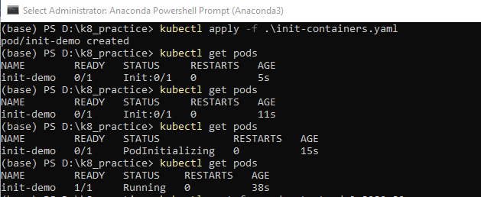

In order to expose the nginx container, so that it can be accessed from browser, ran this command:

*kubectl port-forward init-demo 8080:80*

This Helped in accepting connections as can be seen in this screenshot:

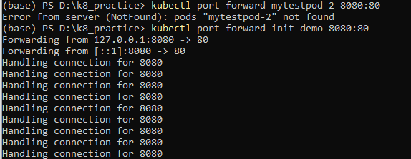

Finally opened the page from browser which is available at localhost:8080

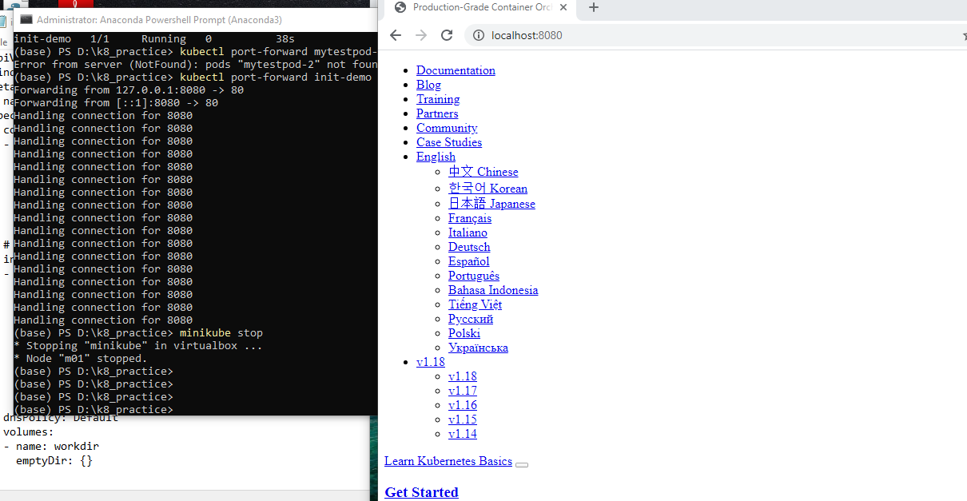

Configuring probes:

Updated the yaml file as follows:

**apiVersion**: v1

**kind**: Pod

**metadata**:

**name**: init-demo

**spec**:

**containers**:

**- name**: nginx

**image**: nginx

**ports**:

**- containerPort**: 80

**volumeMounts**:

**- name**: workdir

**mountPath**: /usr/share/nginx/html

**livenessProbe**:

**exec**:

**command**:

- cat

- /usr/share/nginx/html/index.html

**initialDelaySeconds**: 5

**periodSeconds**: 5

**initContainers**:

**- name**: install

**image**: busybox

**command**:

- wget

- "-O"

- "/work-dir/index.html"

**- http**://kubernetes.io

**volumeMounts**:

**- name**: workdir

**mountPath**: "/work-dir"

**dnsPolicy**: Default

**volumes**:

**- name**: workdir

**emptyDir**: {}

Created pod with this updated definition and verified that the probes are in effect

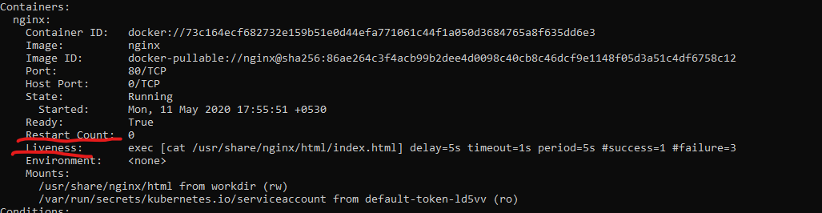

Takeaway: Yamllint is useful application to check and correct yaml indentation.